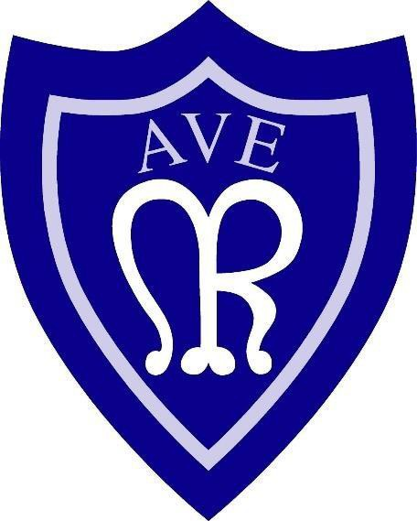

Our Lady of the Rosary

Catholic Primary School

PE Policy

2024-25

# Introduction

PE in Our Lady of the Rosary School is promoted as one of the tools to help tackle childhood obesity. Every year the statistics suggest that nearly 2/3 of all 10 and 11 year olds classed as overweight or worse. It was recommended that children access 30 minutes of exercise per day and 2 hours of Physical education per week. Our children are encouraged to join in active break times in order to provide them with this recommended daily amount. Active break times include taking part in the daily mile each day. They also access 2 hours of Physical education a week lead by their teacher.

# Aims & Objectives

Physical education develops the children’s knowledge, skills and understanding so that they can perform with increasing competence and confidence in a range of physical activities. These include dance, competitive games, gymnastics, swimming, athletics and opportunities to take part in many other games and sports. Physical education promotes an understanding in children of their bodies in action. It involves thinking, selecting, and applying skills and promotes positive attitudes towards a healthy lifestyle. Thus, we enable them to make informed choices about physical activity throughout their lives.

The aims of PE are:

* to enable children to develop and explore physical skills with increasing control and coordination.
* to encourage children to work and play with others in a range of group situations.
* to develop the way children, perform skills and apply rules and conventions for different activities;
* to increase children’s ability to use what they have learnt to improve the quality and

control of their performance.

* to teach children to recognise and describe how their bodies feel during exercise.
* to develop the children’s enjoyment of physical activity through creativity and

imagination;

* to develop an understanding in children of how to succeed in a range of physical activities and how to evaluate their own success;
* to develop the children’s aspirations to be the best they can be and represent the school in competitive sport to promote a healthy lifestyle through teachings in PSHE.

# Teaching & Learning

We use a variety of teaching and learning styles in PE lessons. Our principal aim is to develop the children’s knowledge, skills and understanding and we do this through a mixtureof whole-class teaching, paired work, small groupings and individual activities. Teachers draw attention to good examples of individual performance as models for the other children and we encourage the children to evaluate their own work as well as the work of other children. Within lessons, children are given the opportunity to collaborate and to compete with each other, and they have the opportunity to use a wide range of resources. We value the children giving 100% at their own level of ability in each session.

In all classes there are children of differing physical ability. Whilst recognising this fact, we provide suitable learning opportunities for all children by matching the challenge of the task to the ability of the child. We achieve this by setting personal and achievable targets which promotes the children’s self esteem and inspires them to want to achieve more.

All key stage 2 classes, that are not yet competent at swimming 25m with good technique have the opportunity to attend additional swimming tuition at the end of the summer term each year. By the end of Key Stage 2 we aim for all children to be able to achieve the national recommendation of swimming 25m competently, as well as being able to perform safe self rescue.

# Planning

PE is a foundation subject in the National Curriculum. In both KS1 and KS2 we teach dance, gymnastics, athletics and games. The games include tag rugby, netball, basketball, hockey, tennis, football and rounders. KS2 children are also taught to swim, or improve their swimming, where possible, if they can already swim confidently and competently.

The curriculum planning in PE is carried out in three phases (long-term, medium term and short-term). The long-term plan maps out the PE activities covered in each term during the key stage.

Our medium-term plans are derived from a need to meet the objectives within each section of the long term planning. They give details of each unit of work for each term. These plans define what we teach and ensure an appropriate balance and distribution of work across each term.

Class teachers/external members of PE staff complete a weekly plan for each PE lesson. These list the specific learning objectives for each lesson and give details of how the lessons are to be taught and what equipment is to be used. In PPA time PE lessons are incorporated and these sessions are delivered by qualified coaches within their area of expertise.

We plan the PE activities so that they build upon the prior learning of the children. While there are opportunities for children of all abilities to develop their skills, knowledge and understanding in each activity area, there is planned progression built into the scheme of work, so that the children are increasingly challenged as they move up through the school.

# Teaching PE to children with Special Educational Needs (SEN)

We teach PE to all children, whatever their ability. Teachers provide learning opportunities that are matched to the needs of children with learning difficulties, and work in PE is tailored to the targets set for individual children in their Individual Education Plans (IEPs).

# Assessment and recording

Teachers assess children’s work in PE as they observe them working during lessons. They record the progress made by children and collect photographic evidence and pupil voice. At the end of a unit of work, teachers make a judgement, recording the child’s attainment and decide whether the child is age expected, above or below. They record this information and use it to plan the future work of each child.

# Resources

There are a wide range of resources to support the teaching of PE across the school. We keep most of our PE equipment in designated PE storage areas, and this is accessible to children only under adult supervision. The hall contains a range of apparatus which will only be assembled by trained operatives/staff. The children use the school field and/or the school yards. Peterlee leisure centre is used for swimming lessons.

# Health and safety

The general teaching requirement for health and safety applies in this subject. We encourage the children to consider their own safety and the safety of others at all times. We expect them to change for PE into the agreed clothing for each activity.

We expect teachers to set a good example by wearing appropriate clothing when teaching PE. The children are to wear trainers in the school hall when partaking in any sport, apart from gymnastics where barefoot is acceptable. School policy is that no jewellery is to be worn for school.

# Monitoring and review

The monitoring of the standards of children’s work and of the quality of teaching in PE is the responsibility of the PE subject leader. The work of the subject leader also involves supporting colleagues in the teaching of PE, being informed about current developments in the subject, and providing a strategic lead and direction for the subject in the school. The PE subject leader gives the headteacher an annual summary report of achievements made by the numerous school teams.

# Competitive Sport

Our school is part of the East Durham Sports network. We endeavour to participate in many competitions, in as many different sports as possible. This introduces a competitive element to sport and allows the children to put into practice the skills that they have developed in their lessons. These opportunities foster a sense of team spirit and cooperation amongst our children. It also enables them to compete against other children who have increasing levels of skill and ability. We will also join in festivals for KS1 and EYFS children.

# Extra-curricular activities

The school provides a range of PE-related activities for children at the end of the school day. These encourage children to further develop their skills in a range of the activity areas. The school sends details of the current club activities to parents when available. This provision is for all children and all abilities and they are sometimes delivered by outside agencies.

Other extra-curricular activities consist of team practice for competitive sport and it is offered to selected pupils.

# PE across the curriculum

**English**: PE contributes to the teaching of English in our school by encouraging children to describe what they have done and to discuss how they might improve their performance.

**Maths**: We use mathematics skills to support PE teaching when appropriate. The children need to be able to time, estimate and measure performances.

**Personal, social and health education (PSHE) and citizenship**: PE contributes to the teaching of personal, social and health education and citizenship. Children develop knowledge of the benefits of exercise and healthy eating. This prepares them to make informed choices about these things which will hopefully lead to a healthy future. From this they can feel empowered to take ownership of their ownlifestyle.

**Spiritual, moral, social and cultural development:** The teaching of PE offers opportunities to support the social development of our children through the way we expect them to work with each other in lessons. Groupings allow children to work together and give them the chance to discuss their ideas and performance. Their work in general enables them to develop a respect for other children’s levels of ability, and encourages them to co- operate across a range of activities and experiences. Children learn to respect and work together to develop a better understanding of themselves and their peers.

**Science:** The teaching of PE offers opportunities to support Science. It links well to the healthy eating topic and also the circulatory system. Children will understand that to get optimum performance from themselves they need to be aware of the ‘fuels’ needed to put into their bodies in order to get out of an activity what they need.