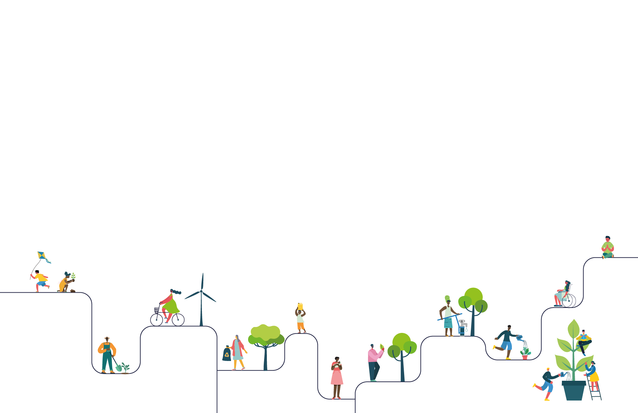

SCHOOL NAME: Our Lady of the Rosary RC School

CONTACT NAME : Sarah White

Thank you for registering your LiveSimply action plan.

The details you entered online are listed below.   
Should you have any queries, please visit [cafod.org.uk/LiveSimplySchools](https://cafod.org.uk/campaign/livesimply-award/livesimply-award-for-schools) for the FAQs

Your **Live**Simply action plan Sarah a3RQ2000000DsozMAC

**Global Actions**

**Action 1 *Living in Solidarity main action***

1B) ___ We will raise funds to purchase CAFOD World Gifts. The whole school can fundraise together, or each class can choose how they will fundraise. Pupils can be involved in choosing the gifts. (Living in Solidarity)

**Global Faith element 1**

The children have raised money for charity and CAFOD in the past and supported the Mini Vinnies turning concern into action. They pray for those who need it and now want to act upon what we talk about. We worked as a whole school and discussed what we could do to help others. Our first question was always 'What would Jesus want us to do?' Followed by 'How can we live more like Jesus?' The children have recognised that Jesus did not just talk about helping others but the he acted and helped them.

**Global Learning element 1**

That we are all not as fortunate as each other and tat we need to help our neighbours whether they are in our school, community, country or world. That we all belong to the family of God and deserve to be treat and respected as equals.

**How will you involve the wider community taking part in the action i.e. governors/families/parishioners/local people**

All stakeholders will be invited in to see the progress we make with raising the funds to purchase CAFOD world gifts and it will be reported on via newsletters, the bulletin in church and social media.  
When we have some of the fundraising events we would like to invite the local community and families in to join us in raising money.

**Would you like a CAFOD visitor to deliver an assembly/workshop to support your CAFOD fundraising action?** No visit is required

**Action 2**

2C) ___ We will engage with Fairtrade and introduce actions to support it (e.g. hold a Fairtrade stall, switch to Fairtrade products in the tuck shop, ask each family to swap at least one item for a Fairtrade product). (Living in Solidarity)

**Global Faith element 2**

Through the RE, PD and Catholic social teaching sessions the children have had they understand the importance of being fair to everyone. They have discussed the working conditions across a number of different countries and have had sessions on equality. Again is this how we treat out neighbours? The children want a world that is fair and just.

**Global Learning element 2**

They will understand the importance of everyone being paid and treat correctly for the work they do, that everyone has a right to a fair and just world. They will understand that any of us could have been born anywhere in the world and we need to work together to ensure that it is fair for all as we would want that help if it was us.

**Action 3**

3A) ___ We will take part in International Day of Peace or World Day of Peace. Included within our actions for this day, pupils will write prayers for our global family impacted by war and conflict. (Living Simply)

**Global Faith element 3**

The children are very confident within school at reflecting on what has happened and making peace between each other if they have a disagreement with a friend or family member. The teaching that has already happened will underpin their new understanding of what it means to pray for peace across the world. We will explore where it may not be peaceful and how our prayers can be heard. The power of prayer is important in our school and is something we talk about regularly.

**Global Learning element 3**

The children will learn and understand on a deeper level about praying for someone who they have never met and that this could be happening for them. That together we can make a change and support our neighbours around the world in trying to achieve peace, that there is no reason for hatred between countries and or communities.

**Local Actions**

**Action 1**

1B) ___ Pupils will write prayers and we will invite parents/parishioners and the local community to share time with us in prayer in our school (e.g. in a prayer garden or a special part of the school grounds/building). (Living Simply)

**Local Faith element 1**

The children have a prayer room in school which has provided lots of opportunities for us to come together to pray and celebrate. This now needs to be extended to the wider community and to create another area, the children talk about the beauty of the natural world and as a school we need to explore this more by creating a prayer garden where we can pray and worship together as one.

**Local Learning element 1**

How importants God's world is and that it belongs to everyone and not just us. That it is a place to be thankful for and that we need to take time out of our busy day to marvel at what God created. It is also important for the children to understand that prayer can happen everywhere and that they do not need to be inside to do it.

**Action 2**

2B) ___ Pupils will work to support the local community in a variety of ways (e.g. praying, cards of kindness, supporting the lonely. (Living Simply)

**Local Faith element 2**

Faith will inspire the pupils to acknowledge that at times we all need support and kindness and we are not all as fortunate to have our families and friends there to support us.  
That the community we come from is our extended family and that we can share kindness and love by the simple tasks. There are a umber of parishioners who come in to school and work with the children and they talk about how their faith journey has lead them to our school. This will help the children to explore how their faith journey can lead them to help others just as our parishioners help us.

**Local Learning element 2**

That simple and small acts of kindness go a long way and that they are not taken for granted. The children will learn how all these small things that we consciously make the effort to do last with people for a long time and that it helps to build up our own souls and spread happiness by doing good to ourselves. Understanding that if everyone does a simple small act the difference we can make together in our community is huge.

**Action 3**

3B) ___ We will support our local foodbank. Pupils will be involved with organising, promoting, and checking the donations. Where possible we will visit a local foodbank or invite a representative to school to share more about their work. (Living in Solidarity)

**Local Faith element 3**

To live like Jesus is important and follow his teachings, the children will reflect on the Gospel reading where Jesus shares the bread and fishes and feeds the hungry. What could we do to support and help the hungry. What would you want people to do for you if it was you? Think about caring for a looking after our neighbours and what this means.

**Local Learning element 3**

They will understand that when we talk about the poor and hungry that it is people in their local community, not just people who are across the world in another country who we will never meet. That we can make a difference to children in the local area who get up and go to a school just down the road.

**School Actions**

**Action 1 – Living Simply main action**

1A) ___ We will create/develop a prayer garden/outdoor spiritual space involving all pupils in some way (e.g. design, creation, prayer stones, planting bulbs, scattering seeds, creating prayers, leading worship). (Living simply)

**School Faith element 1**

Learning about the beauty of God's wonderful world and how we need to appreciate it and care for it.  
Extending on from our prayer room and the way in which the community come in and worship and celebrate with us.  
To be able to have another space in school where we can appreciate the world that God make and help to care for it.

**School Learning element 1**

That the earth is a gift and that we need to care for it as God does for us, that he is always present and we can prayer in any quiet space whether it is indoors or out.

**How will the school be involving the wider community in their Living Simply action**

The wider community will be invited in to join classes and groups in the prayer garden and to share in caring for it. We are hoping to host a day of reflection in school for the wider community and all stakeholders and this will be a perfect opportunity for them to be welcomed in and spend some time in nature reflecting and celebrating.

**Action 2 – Living Sustainably main action**

2C) ___ We will take action to Rethink, Refuse, Reduce, Reuse, Repair, Regift, Recycle. Pupils will be involved in implementing, raising awareness, and taking part in actions. (Living Sustainably)

**School Faith element 2**

We will reflect on the world that God has created for us and are we caring for it as we should, what happens when we throw away unwanted or unused items. Does this show we are living as Jesus wanted us to.

**School Learning element 2**

That everything we use and throw away does not just simply disappear, this it stays on earth and we should think about how best to look after the earth and recycle or reuse.

**How will the school be involving the wider community in their Living Sustainably action**

By sharing the messages in Family Fridays (assemblies where the whole school shares about what they have been learning and completes activities with their families) and in newsletters - creating their own posters and information leaflets to be shared online and in church.

**Action 3**

3C) ___ Inspired by Laudato Si' we will help protect the environment by cutting our carbon footprint, encouraging walking/scooting/cycling to school and appreciating our environment (e.g. pupils to look for God's creations on their journey and share what they have spotted). (Living Sustainably)

**School Faith element 3**

using the inspiration from Laudato Si' and reminding children that the world is a gift from God that we need to nurture and care for, we are all Gods creations and need care.

**School Learning element 3**

To appreciate the beauty of Gods creations and to look after the world. To think of new ways in which we can all make a difference together by walking to school. The difference it can make to the local environment and both our physical and mental health.

**Main Actions**

**Living** Simply

1A) ___ We will create/develop a prayer garden/outdoor spiritual space involving all pupils in some way (e.g. design, creation, prayer stones, planting bulbs, scattering seeds, creating prayers, leading worship). (Living simply)

**Living** Sustainably

2C) ___ We will take action to Rethink, Refuse, Reduce, Reuse, Repair, Regift, Recycle. Pupils will be involved in implementing, raising awareness, and taking part in actions. (Living Sustainably)

**Living** inSolidarity

1B) ___ We will raise funds to purchase CAFOD World Gifts. The whole school can fundraise together, or each class can choose how they will fundraise. Pupils can be involved in choosing the gifts. (Living in Solidarity)

**School/Contact Details**

**Name of School**

Our Lady of the Rosary RC School

**Address**

Westway

Peterlee

SR8 1DE

**Phone**

01915862264

**Contact Name**

Sarah White (Mrs)

**Email Address**

swhite@ourladyrosary.org.uk

Any queries please view our FAQ on [www.cafod.org.uk/LiveSimplySchools](http://www.cafod.org.uk/LiveSimplySchools) or email [schools@cafod.org.uk](mailto:schools@cafod.org.uk)