Our Lady of the Rosary Catholic Primary School

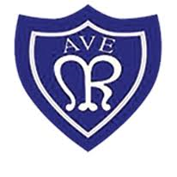

Uniform & Equipment Policy

2023 - 2024

Contents

- Introduction
- Main School Uniform & Equipment
- PE Uniform
- Outdoor Play and learning
- Accessories, Hair and Make up
- The role of the Governing Body/IAB
- Monitoring & Review

Introduction

Our uniform shows that we are part of Our Lady of the Rosary Catholic Primary School community. We have high standards with regards to school uniform and appearance and expect families to work with us in supporting this.

School specific items are available from Little Gems stores or online, please contact Little Gems store in Sunderland for further information. The items detailed are also readily available from the high street – if parents and carers find any item difficult to obtain, please contact the school office. Our uniform has been kept simple to avoid unnecessary expense.

We ask parents and carers to support all decisions by school staff regarding whether or not clothing is appropriate or inappropriate for school.

Our policy is based on the belief that school uniform has the best interests of our pupils at heart by:
  - promoting a sense of pride and respect in our school
  - helping to create a sense of community and belonging
  - ensuring equality and equity
  - being practical and designed with health and safety in mind, particularly in line with our active day and engaging in outdoor play and learning
  - is considered good value for money

Nursery Uniform

Uniform
- School jumper or cardigan-red  - Red polo shirt (it does not have to have the school logo on)  - Black/grey trousers or shorts  - Black/grey skirts and pinafore dresses  - Summer dresses-red and white check  - Black school shoes | 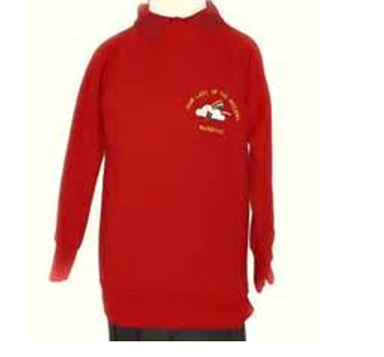

Main School Uniform & Equipment

Girls’ Uniform | Boys’ Uniform
- School jumper or cardigan  - White polo shirt (it does not have to have the school logo on)  - Black/grey trousers or skirt/pinafore  - Black school shoes or plain black trainers (no logos or markings)  - White or grey socks or black/grey tights  *No leggings or lycra skirts | - School jumper or cardigan  - White polo shirt (it does not have to have the school logo on)  - Black/grey trousers  - Black school shoes or plain black trainers  - Grey or black socks
Girls’ Summer Uniform Alternatives | Boys’ Summer Uniform Alternative
- Light blue checked school dress  - Grey shorts | - Grey shorts
Additional Equipment
- Named water bottle
- Book bag or alternative
Please note: our children are active every day in school, not just in PE lessons therefore short/lycra skirts are not appropriate. Similarly, leggings, jeggings and jeans are not acceptable.

Footwear:
- Pupils must wear closed-toed, hard-soled, all black plain shoes with a flat sole.
- If black trainers are worn as school shoes, they should be plain black with no coloured logos.
- Footwear with flashing lights is not appropriate for school.
- If boots are worn these should also be plain black.
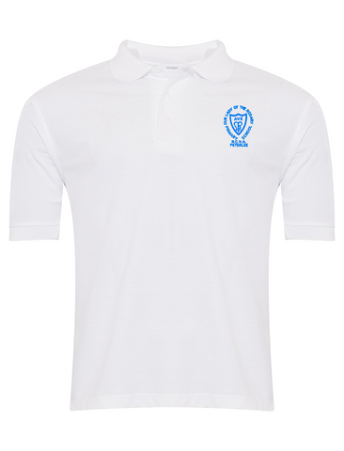
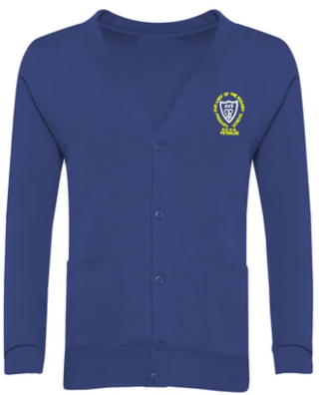
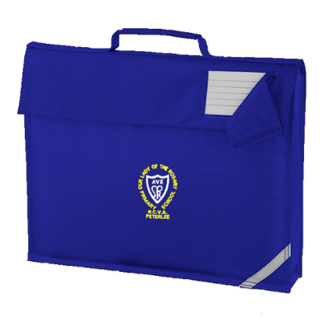
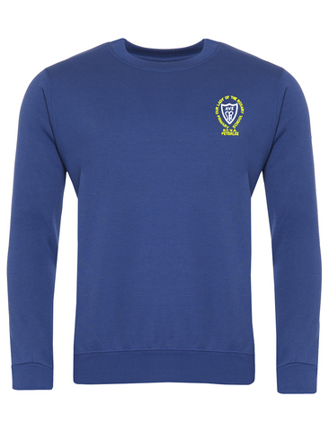

PE Uniform
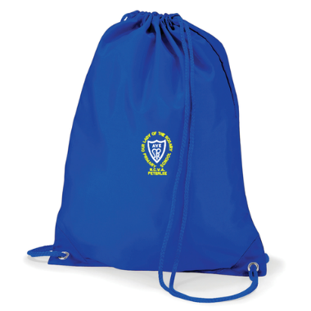
PE Kit
- Plain white T shirt
- Plain blue or black shorts
- School jumper (if outside)
- Plain blue or black leggings/tracksuit bottoms
- Trainers
- PE bag to be left in school from Monday to Friday (or ½ termly)

Outdoor Play and Learning
Our pupils have access to outdoor spaces throughout the school year and, unless weather conditions are extreme, will be able to go out and play IF they have suitable clothing and footwear.

At different times of year, your child may need:
- Waterproof coat
- Hat / gloves / cap
- Sun cream
- Wellingtons

Accessories, Hair and Make Up
- For health and safety reasons we do not allow children to wear jewellery at all.
- Wrist watches may be worn but only for the purpose of telling the time. ‘Smart’ watches linked to mobile phones or with games on are not permitted e.g Apple/Vtech. Watches must be removed prior to PE lessons.
- Hair bands, ribbons/bows or ‘scrunchies’ should be plain. Hair bands should not have large flowers/cat ears attached.
- Make up and nail varnish must not be worn to school. False nails must not be worn.
- Extreme hairstyles are not appropriate for school. The use of styling products should be kept to a minimum and children should not have decorative patterns or ‘tram lines’ cut into their hair or have their hair coloured or dyed.
- For health and safety reasons and to ensure it does not distract from learning, long hair should be tied back.

Hats, Headscarves or Headwear
Pupils are not allowed to wear hats, headscarves, or any other head covering inside the school building unless it is due to religious or cultural reasons.

Non-Compliance with Uniform Policy
Parents and carers of pupils that do not wear their uniform correctly will be contacted and asked to bring in the missing uniform. If this is not possible then pupils will be provided with the uniform, they are missing for that day. The parent or carer will then be asked to discuss the issue at the end of the day. There may be good reasons why a child is not wearing school uniform. In this case, parents and carers should share the reasons with the Executive Headteacher/Deputy Headteacher either in person or by letter.

The school will always be considerate and discrete in trying to establish why a pupil is not wearing the correct uniform. Pupils will not be made to feel uncomfortable, nor discriminated against, because their parents are unable to provide them with the required items of school uniform. We encourage discussion with the school at the earliest opportunity if there are any difficulties.

There will be occasions when the school decides that school uniform is not appropriate e.g. when taking part in a physical activity day or wearing different clothes as a part of a fund-raising event. Parents and carers will be notified in advance of what is the revised dress code on these days.

Pupils who wear make-up/nail varnish or jewellery will be required to remove these. Items of jewellery will be confiscated by the teacher to be collected by the parent. Staff will not remove earrings for pupils – parents will be telephoned to come to school and remove earrings before children can take part in continuous provision in EYFS, play times and any active lessons.

Lost Property
Naming Clothing and Property is VERY IMPORTANT – Please ensure all clothing and property is clearly marked so that lost articles may be easily traced and returned. The school cannot accept responsibility for loss or damage of pupils’ property and valuables.

All mislaid items are sent to the school office. Please ask the school office if you wish to look through the lost property box. We endeavour to return all named property.

Racial Equality & Equal Opportunities
All children have equal access to wearing school uniform regardless of their culture, race, religion, gender, disability or ability. We ensure that the set uniform respects other policies and allows for individual sets of circumstances of all groups and individuals.
Our Lady of the Rosary Primary school is committed to creating a positive climate that will enable everyone to work free from racial intimidation and harassment and to achieve their full potential.

The Role of the Governing Body/IAB
The governing body supports the headteacher in implementing the school uniform policy. It considers all representations from parents regarding the uniform policy and liaises with the headteacher to ensure that the policy is implemented fairly and with sensitivity. It is the governors’ responsibility to ensure that the school uniform meets all regulations concerning equal opportunities and poverty proofing. Governors ensure that the school uniform policy enables children to dress sensibly, in clothing that is hard wearing, safe and practical.
The governing body monitors and reviews the school uniform policy through its committee work by:
  - seeking the views of parents, to ensure that they agree with and support the policy
  - considering, with the headteacher, any requests from parents for individual children to have special dispensation with regard to school uniform

Monitoring & Review

This policy will be reviewed annually and links to the following policies and procedures:
Child Protection policy
Equal Opportunities
Health & Safety
SEN

