 | Week 1 | Week 2 | Week 3 | Week 4 | Week 5
Spelling focus | Y making an I sound | String ‘ough’ | String ‘ough’ | String ‘ough’
Example spelling words | Rhythm  Sympathy  Myth  Pyramids  Physical  Systems  Symbols  Mystery | Fought  Nought  Sought  Afterthought  Thought  Ought | Cough  Rough  Thorough  Although  Tough  Through | Plough  Dough  Borough  Brought  Enough  Bought
Web links
Here is an overview of the spelling rules your child will be learning this half term. Please support your child to practise these spellings using a range of strategies. We have included links and ideas to support their learning.
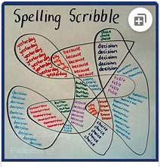
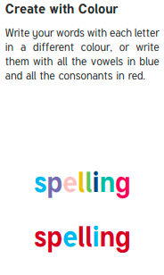
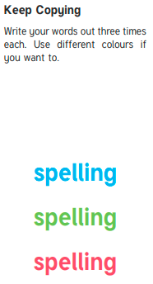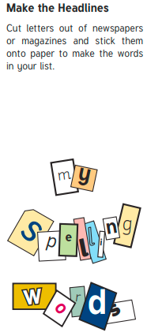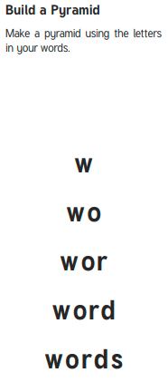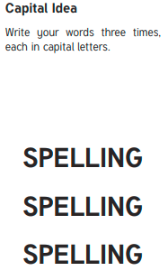
Backwards Words
Write your spelling words forwards and then backwards. Write neatly!

Example where erehw

