 | Week 1 | Week 2 | Week 3 | Week 4 | Week 5 | Week 6
Spelling focus | Y making an I sound | String ‘ough’ | String ‘ough’ | String ‘ough’ | Homophones Recap | Homophones Recap
Example spelling words | Rhythm  Sympathy  Myth  Pyramids  Physical  Systems  Symbols  Mystery | Fought  Nought  Sought  Afterthought  Thought  Ought | Cough  Rough  Thorough  Although  Tough  Through | Plough  Dough  Borough  Brought  Enough  Bought | Through  Threw  Bored  Board  Aloud  Allowed  Would  Wood | There  Their  They’re  Hear  Here  Where  Wear  Weather  Whether
Web links | Word list activities: Short /i/ spelled y: Set 1 (spellzone.com) | Word list activities: Short /i/ spelled y: Set 1 (spellzone.com) | Word list activities: Short /i/ spelled y: Set 1 (spellzone.com) | Word list activities: Short /i/ spelled y: Set 1 (spellzone.com) | Homophones - English - Learning with BBC Bitesize - BBC Bitesize | Homophones - English - Learning with BBC Bitesize - BBC Bitesize
Here is an overview of the spelling rules your child will be learning this half term. Please support your child to practise these spellings using a range of strategies. We have included links and ideas to support their learning.
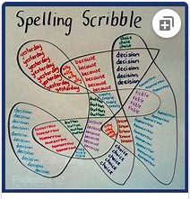
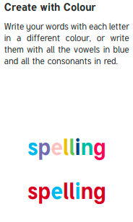
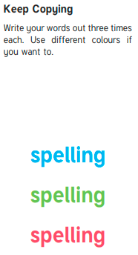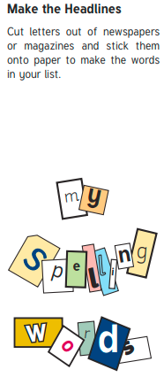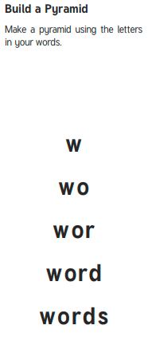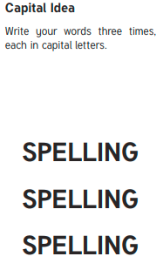
Backwards Words
Write your spelling words forwards and then backwards. Write neatly!

Example where erehw

