 | Week 1 | Week 2 | Week 3 | Week 4 | Week 5 | Week 6 | Week 7 | Week 8
Spelling focus | Words ending in able | Words ending in ible | Words ending in ibly | Words ending in ably | Statutory words | Statutory words | I before e except after c | Statutory words
Example spelling words | Adorable  Considerable  Tolerable  Comfortable  Reliable  Changeable  Noticeable  Knowledgeable  Manageable  beliveable | Impossible  Horrible  Terrible  Visible  Incredible  Accessible  Flexible  Suggestible  Edible  Plausible | Possibly  Responsibly  Sensibly  Visibly  Audibly  Horribly  Terribly  Flexibly  Incredibly  plausibly | Probably  Notably  Memorably  Tolerably  Miserably  Comfortably  Preferably  Regrettably  Remarkably  Justifiably | Available  Vegetable  Forty  Queue  Temperature  Twelfth  Government  Environment  Suggest  Rhyme | Ancient  Soldier  Sufficient  Symbol  Immediately  Bruise  Restaurant  Guarantee  Mischievous  Excellent | Deceive  Conceive  Receive  Perceive  Ceiling  Deceit  Conceit  Receipt  Believe  Relieve | Accommodate  Bargain  Category  Exaggerate  Language  Muscle  Physical  Restaurant  Shoulder  Temperature
Web links | https://spellingframe.co.uk/spelling-rule/35/41-Words-ending-in-able-and-ible-Words-ending-in-ably-and-ibly-1-of-2 | https://spellingframe.co.uk/spelling-rule/35/41-Words-ending-in-able-and-ible-Words-ending-in-ably-and-ibly-1-of-2 | https://spellingframe.co.uk/spelling-rule/35/41-Words-ending-in-able-and-ible-Words-ending-in-ably-and-ibly-1-of-2 | https://spellingframe.co.uk/spelling-rule/35/41-Words-ending-in-able-and-ible-Words-ending-in-ably-and-ibly-1-of-2
Here is an overview of the spelling rules your child will be learning this half term. Please support your child to practise these spellings using a range of strategies. We have included links and ideas to support their learning.
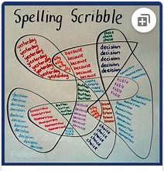
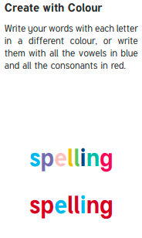
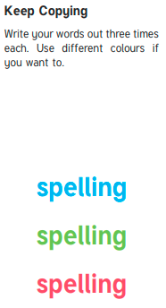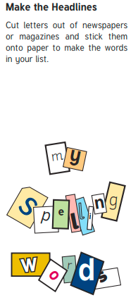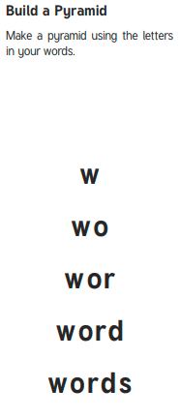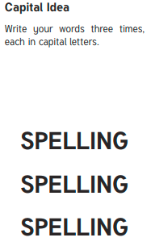
Backwards Words
Write your spelling words forwards and then backwards. Write neatly!

Example where erehw

