 | Week 1 | Week 2 | Week 3 | Week 4 | Week 5 | Week 6 | Week 7
Spelling focus | Homophones | Homophones | Homophones | Words ending in -cious/tious | Words ending in- cious/tious | Words ending in- cious/tious | Statutory Words
Example spelling words | Aisle  Isle  Affect  Effect  Morning  Mourning  Aloud  Allowed | Advice  Advise  Device  Devise  Led  Lead  Past  Passed | Farther  Father  Guessed  Guest  Dessert  Desert  Steal  Steel | Conscious  Ambitious  Infectious  Nutritious  Malicious | Vicious  Precious  Suspicious  Cautious  Fictious | Suspicious  Gracious  Tenacious  Spacious  Delicious | Cemetery  Convenience  Criticise  Excellent  Existence  Hindrance  Necessary  Prejudice  Sacrifice
Web links | English KS2: Homophones - BBC Teach | English KS2: Homophones - BBC Teach | English KS2: Homophones - BBC Teach | Which words end with -cious and -tious? - BBC Bitesize | Which words end with -cious and -tious? - BBC Bitesize | Which words end with -cious and -tious? - BBC Bitesize | SpellingWordList_Y5-6.pdf (oxfordowl.co.uk)
Here is an overview of the spelling rules your child will be learning this half term. Please support your child to practise these spellings using a range of strategies. We have included links and ideas to support their learning.
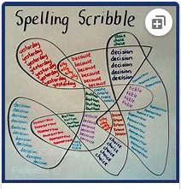
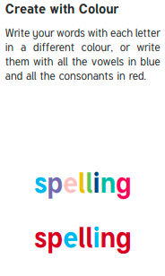
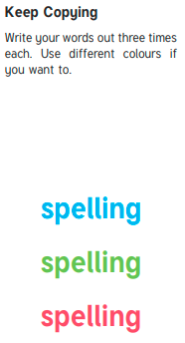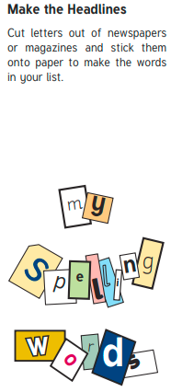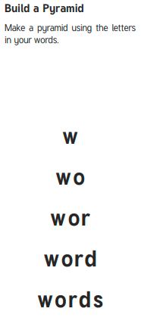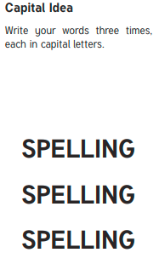
Backwards Words
Write your spelling words forwards and then backwards. Write neatly!

Example where erehw

