Year 5 Autumn 1
Number sense focus
To be able to recall number bonds to 1000.

This half term your child will practise finding number bonds to 1000 every day. This will help them to partition and recall pairs of numbers up to 1000. Below are examples of the possible questions you could give your child in order to practise these facts.

You might begin with multiples of 100
1000 – 300 =
200 + ? = 1000
700 + 300 = ?

You can then move on to random 3 digit numbers – see the example below
You can then move onto multiples of 10.
340 + 660 = 1000
270 + ? = 1000
1000 – 580 =

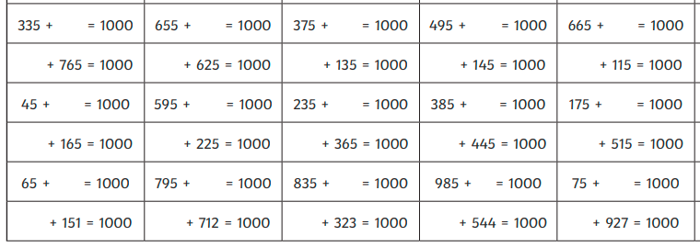

Here are some links to games and resources that will help you child to develop their skills in this area.

https://www.studyzone.tv/game277-code71792b287c7b987c78bfe788c25c635b
https://www.youtube.com/watch?v=VRSPwpsus6s
https://www.topmarks.co.uk/maths-games/mental-maths-train

