

Year 2 Autumn 1

Number sense focus

To know doubles and halves from 10 to 20.

This half term your child will practise doubling and halving numbers from 10 to 20. This will help them to quickly add, subtract, multiply and divide and work out number problems using doubling and halving number facts. This will also help when finding a fraction of a quantity.

You might begin with addition to find double.

5 + 5 = 6 + 6 =

7 + 7 = 8 + 8 =

9 + 9 = 10 + 10 =

=

6 + 6 =

You might divide by 2 to find half.

20 ÷ 2 = 18 ÷ 2 =

16 ÷ 2 = 14 ÷ 2 =

12 ÷ 2 = 10 ÷ 2 =

You might move onto multiplication to find double.

5 x 2 = 6 x 2 =

7 x 2 = 8 x 2 =

9 x 2 = 10 x 2 =

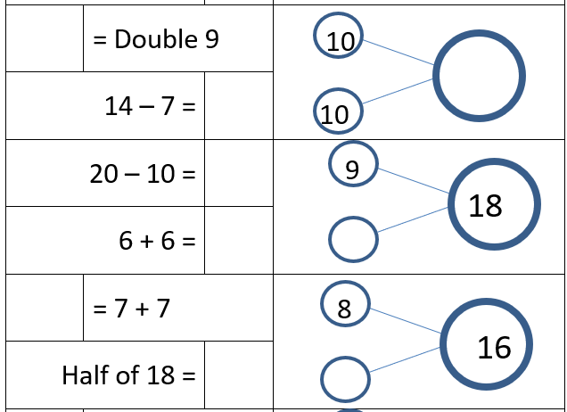

**Here are some links to games and resources that will help you child to develop their skills in this area.**

Option A - Click on doubles 10 – 20

Option B - Click on halves 10 - 20