Year 2 Summer 2
Number sense focus
To multiply and divide by 5.

Building on from previous work, your child will use their knowledge of counting in 5s to quickly multiply and divide by 5. Your child might use their fingers at first, but the aim is for your child to rapidly recall these facts.

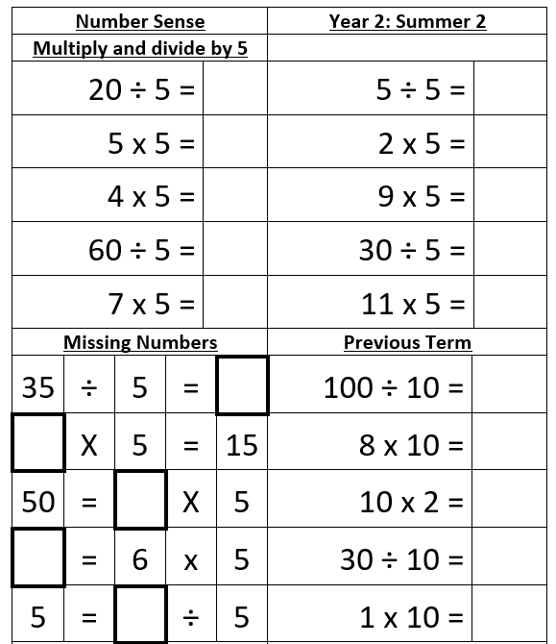

Here are some links to games and resources that will help you child to develop their skills in this area.

Times Table Rock Stars https://play.ttrockstars.com/login/27473
Array Display - https://ictgames.com/mobilePage/arrayDisplay/index.html
Doggy Division dinners - https://ictgames.com/mobilePage/doggyDivision/index.html
Bunny Battlefront (Year 2 version only) - https://ictgames.com/mobilePage/bunny/index.html
Finger Count - https://ictgames.com/mobilePage/fingerCount/index.html

