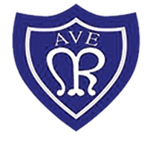
OLOTR: Year 2 – Spider Monkeys

Class Newsletter April 2023
WELCOME BACK  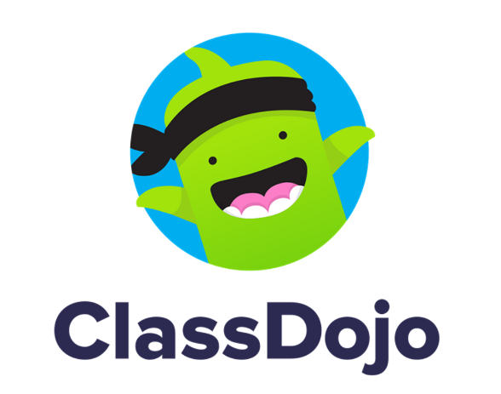  I can’t believe how quickly this school year has gone so far! Who would believe that we only have one term left in year 2 before moving into Key Stage 2! Remember to check out Dojo every day for a snapshot of the learning that takes place in class.  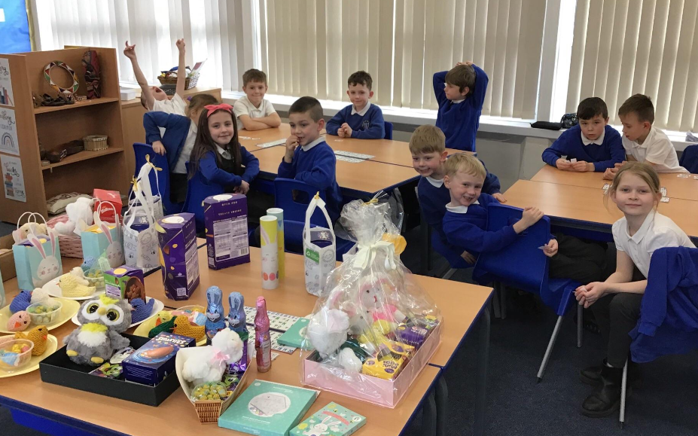  Things to remember  P.E – PE is every Monday and Wednesday. Please keep your full PE kit in school until the May half-term holiday.  Reading – Bring your reading book and reading record every day. Try and read every night but remember to get your book signed at home to earn a raffle ticket.  Year 2 closed due to teacher strike on Thursday 27th April and Tuesday 2nd May 2023.  Year 2 trip to Washington Wetlands Centre on Wednesday 26th April 2023. Please dress for the weather!  Public bank holidays – Monday 1st May and Monday 8th May 2023.  Half term holiday Monday 29th May – Friday 2nd June 2023. School closed Friday 26th May.  School re-opens Monday 5th June 2023.  Class liturgy with parents – 16th June 2023 at 9:00am  20th June 2023 – Year 2 summer litter pick at Crimdon Dene | OUR Curriculum  We have an action-packed summer term planned. In science, we are learning about plants. In art, we are making African masks which links to our work in Africa on Kenya. In History, we will be comparing queens who reigned in the UK, including our very much loved and remembered late Queen Elizabeth 11. To celebrate the king’s coronation, we have a celebration planned in school, including a themed coronation menu for lunch on 5th May. In computing we are creating branching databases linked to science. In RE, we will be learning about Pentecost.  National Curriculum Assessments  During the month of May, your child will complete assessments, often known as SATS. Please try to ensure your child is in school during the month of May. The tests are as follows:  Maths paper 1 – Arithmetic & Maths paper 2 – Reasoning  Reading paper 1 & Reading paper 2  Spelling paper & Grammar and punctuation paper  Test scores alongside teacher assessment will be used to make final teacher judgements and progress will be reported to parents at the same time they receive their children’s end of year school reports. This will be in July 2023. We have been completing practice materials in school and the children have really enjoyed doing these believe it or not! Any questions, please message on Dojo.  We have £20 in our class piggy bank so far for attendance. Let’s see if we can win even more money this term. We can only win this if we have the best attendance that week. We can do it!  We raised £142 in our Grand Class Easter Raffle. Thank you for all your generosity! It was lovely to see everyone walking out with a prize, even if it was something very small! The children said “I wish we could have an Easter raffle every day!” We are donating £20 to CAFOD, buying a few reading raffle prizes and spending the rest on goodies for a celebration end of SATS party! We can’t wait!

