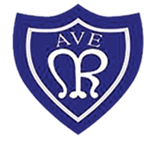
OLOTR: Year 1 – Penguins

Class Newsletter May 2023
WELCOME BACK  Can you believe we are almost at the end of the school year?  I am very proud of what the children have achieved so far, and they have exceeded my expectations in every aspect of year 1 life! Here are a selected few snap shots of the adventures and learning experiences we have had so far.  We went on a trip to Washington wetlands and the children had so much fun searching for and learning about all the different types of wildlife that live there. We got to watch the Otters having their lunch and a duck keeping her eggs warm on her nest! The behaviour throughout the trip was impeccable and the children are a real credit to the school and yourself. Head over to the school website to see more photos.  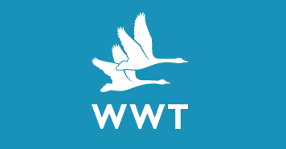  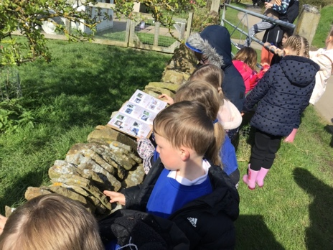  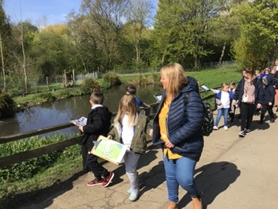  Thank you to everyone who attended the class liturgy. The children really enjoyed letting you share such an important part of school life with them.  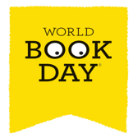  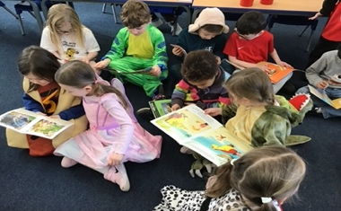  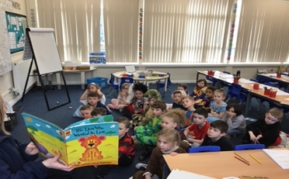  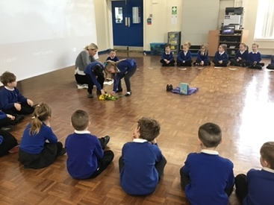  The children celebrated world books day with a range of activities and enjoyed listening to their favourite stories throughout the day. | OUR Curriculum  In science we have been learning all about how plants grow, and we planted and observed our own sunflower seeds. We have also developed a good understanding of different types of materials and their properties and investigated how objects can float and sink!  In history we have been learning about significant woman such as Florence nightingale and Mary Anning. During our RE topic, we have been learning all about why we celebrate Easter and why this is an important religious celebration, as Jesus died on the cross on good Friday and then he was resurrected on Easter Sunday.  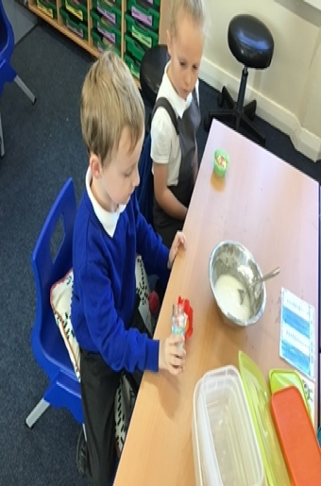  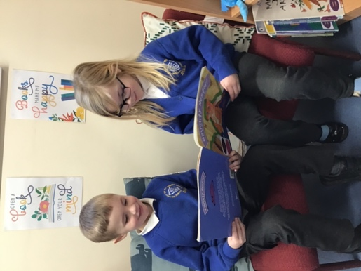  Let’s celebrate  We have been awarded £30 in total for class attendance so far! We have decided to save this as the children have decided they would like a McDonalds as their reward. Please ensure your child attends school to help us gain more.  Things to remember  P.E – PE is every Monday and Tuesday. Please keep your full PE kit in school until the May half-term holiday.  Reading – Bring your reading book and reading record every day.  Public bank holidays – Monday 8th May 2023.  Half term holiday Monday 29th May – Friday 2nd June 2023. School closed Friday 26th May.  School re-opens Monday 5th June 2023.

