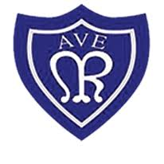

We have enjoyed exploring the season of spring and learning all about growth and new life this term. We have been very lucky to watch our chicks hatch from their eggs and to see our caterpillars grow into beautiful butterflies.

**General information:**

* A reminder that PE is on a Thursday this term. Reception children are to come to school dressed in their PE kit.

**PE Kit uniform is:**  
A plain white t-shirt  
School jumper/cardigan  
Plain black/grey jogging bottoms  
Plain trainers

* Children will be reading every day, reading books need to be returned to school each day. Please read at home as often as possible and leave a comment in your child’s reading journal.
* Do your bit for attendance – please make sure that you contact school if your child is going to be absent.

We enjoyed celebrating Easter with a range of activities. But most importantly we got to taste hot cross buns. They received a big thumbs up.

We visited the prayer stations in the hall. We were very respectful when taking part in the range of activities that supported our understanding of Lent.

We had a special guest in Reception. We had the author Emily Lloyd-Gale zoom call us to share her new book ‘Mighty Maurice’. We really enjoyed listening to her story and loved meeting mighty Maurice.

This meeting has encouraged us to be authors and over the last couple of weeks we have been creating our own fantastic stories.

Look what we have been up to this term…

**Our Lady of the Rosary – Reception Newsletter**

**April 2023**