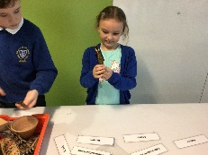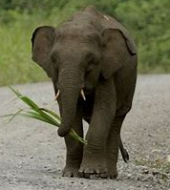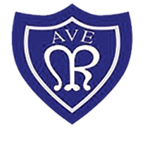

**This half term**

This half term, our reading book is Flat Stanley The Great Egyptian Grave Robbery. The children have enjoyed this book as it links to our history topic of Ancient Egypt.

In Writing lessons, we will be writing a non-chronological report about the Ancient Egyptians. We will then be writing adventure stories.

In maths we will be developing our arithmetic skills through arithmetic lessons and multiplication practice. We will also be solving problems involving area and fractions.

In science we are learning about the digestive system, teeth and food chains. We will be learning through lots of practical lessons and experiments.

in computing we are using able clips to create videos.

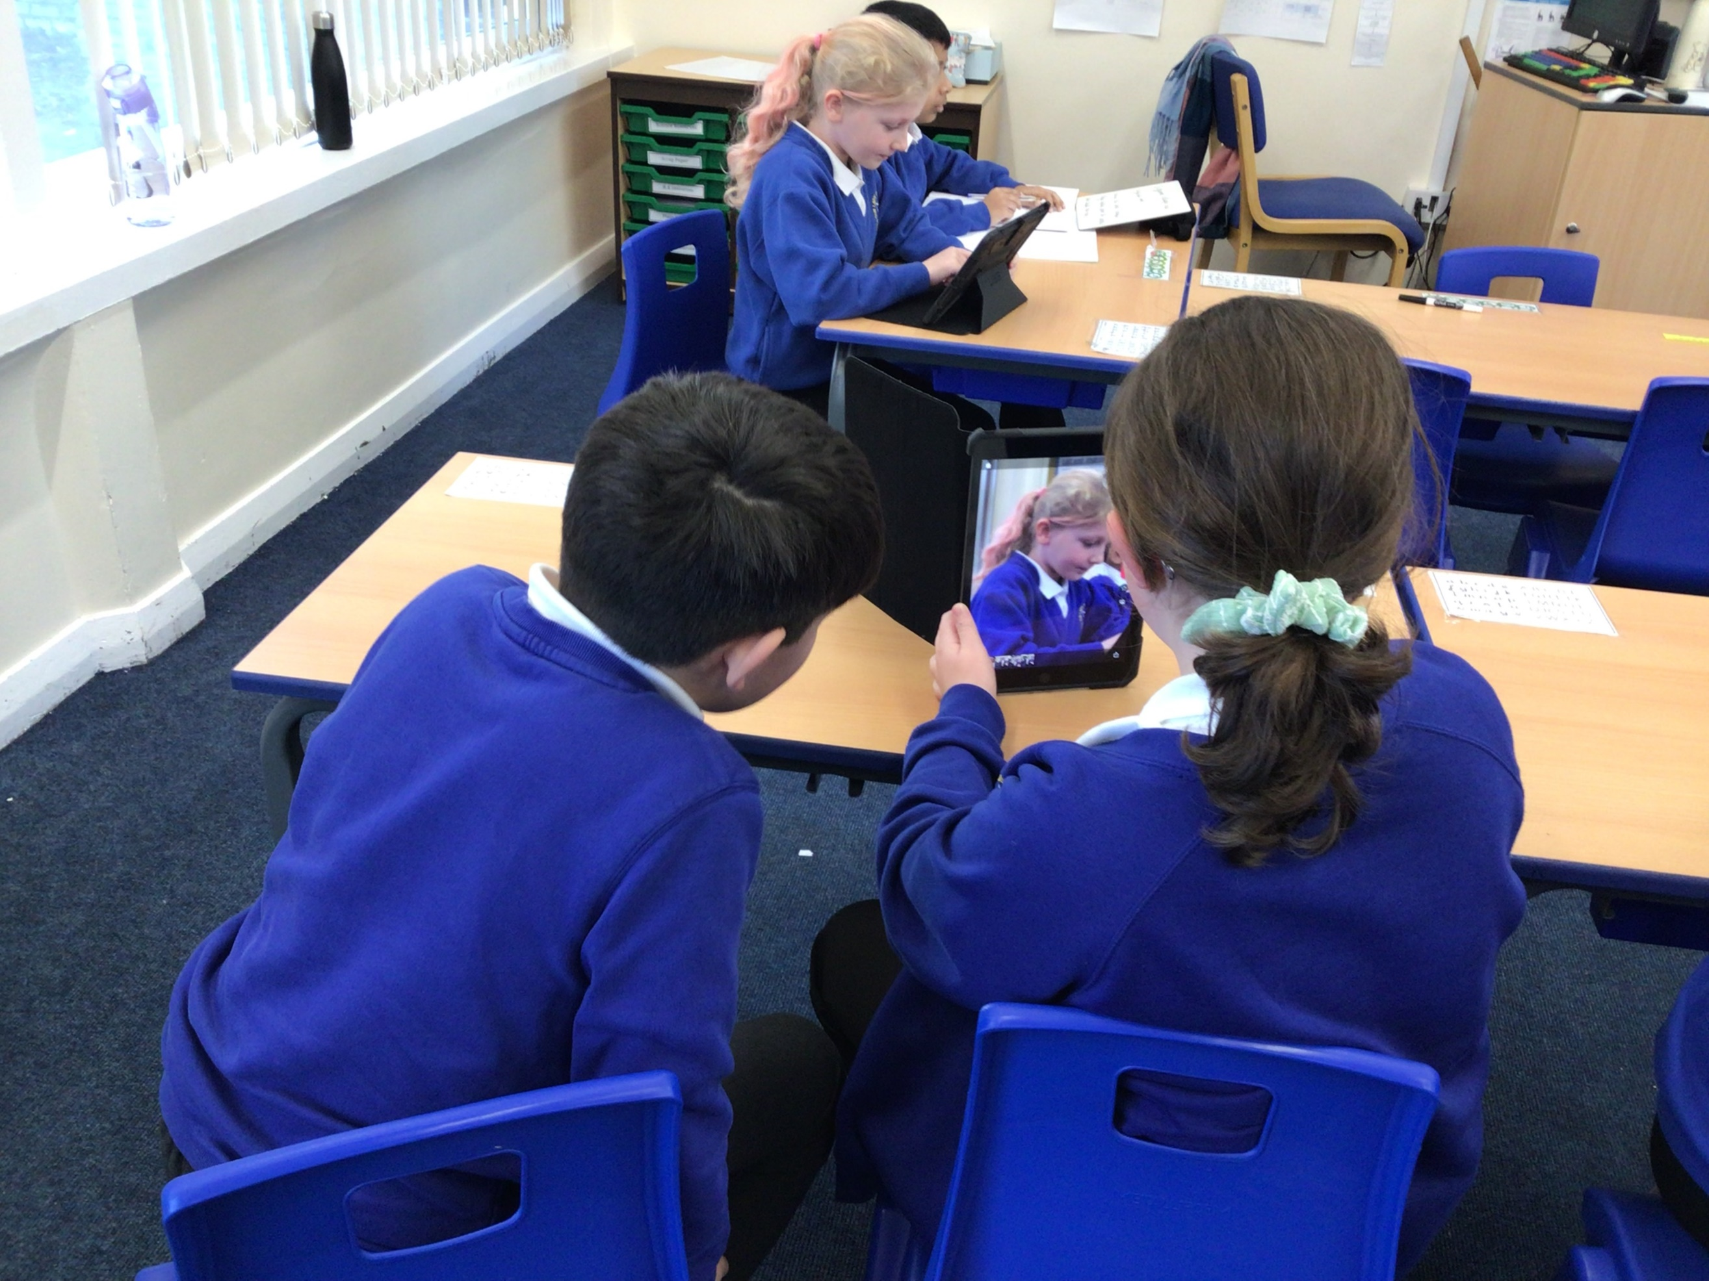

**Next half term we will be**

* Learning about sound and hearing
* Learning about coasts
* Writing biographies
* Solving mathematical problems involving decimals

We will also be reading a new class text.

**Things to do at home**

Reading is a priority at Our Lady of the Rosary and we give the children plenty of opportunities to read at school. Please continue to bring your child’s book and reading record to school daily and try to listen to them read three times a week.

We are also sending home spelling for each half term for your children to practice at home.

In year 4 Times Tables are extremely important as quick recall of multiplication facts supports mathematical learning. Please try to encourage your child to access Times Table Rock Stars. We are also sending home a maths overview for children to practice particular skills each half term.

.

Happy New Year

I hope you had a fabulous Christmas and new year. We had a fantastic time last term. We particularly enjoyed our science topic of material as we did lots of experiments. Another highlight of last term was our school trip to the Hancock Museum. The children really enjoyed the workshop and exploring the museum and even saw a mummified person. The children learnt a lot which they are able to use in lessons in school. I am really looking forward to all the exciting this we have planned this term.

**Our Lady of the Rosary Catholic Primary School**

**Year 4 Pygmy Elephants**

**Class Newsletter January 2023**