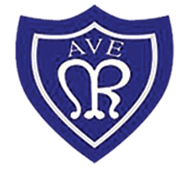
OLOTR: Year 4

Class Newsletter January 2023
Happy new year!  I hope you had a lovely Christmas and a brilliant start to the New Year. The children have come in refreshed and ready to learn. They have settled back into our routine and have loved starting swimming. They are also very excited for our Class Liturgy; we hope to see you there!  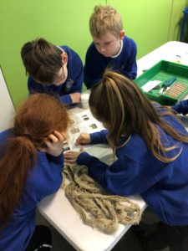  History  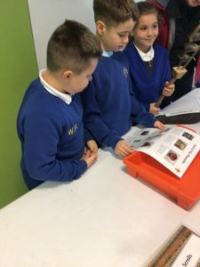  We have carried on our History topic (Ancient Egyptians) from last half term. The children have loved being able to explore Ancient Egypt and find out what life was like for them.  Our trip to the Hancock Museum really helped bring History to life for the children seeing all the artefacts and being able to hold these during our workshop. They have all done brilliant work at home to help build on their knowledge from school and created amazing fact files on one of the Ancient Egyptian gods. | 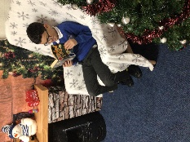  Reading  We have loved seeing how much the children have enjoyed reading in year 4!  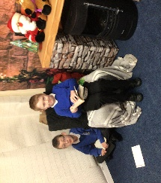  We love to see the comments in their reading records from yourselves and the children’s own messages about how much they loved their books.  We want to encourage the children to continue bringing in their reading records and books every day to read with myself and Mrs Ord.  D.T.  We are super excited to start making our shoes in D.T. The children have picked a celebrity to base their shoes around and have got some amazing ideas on how they want their shoes to look.  If you have any sequins, jewels, or crafts you could bring for the children to use that would really help bring their visions to life!  We cannot wait for you to see the results.

