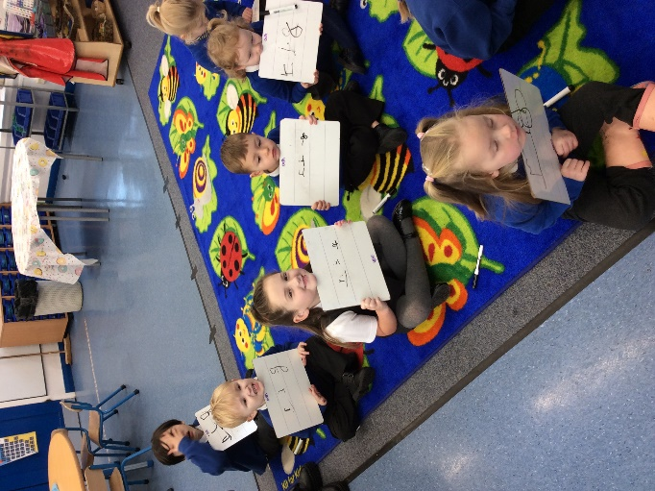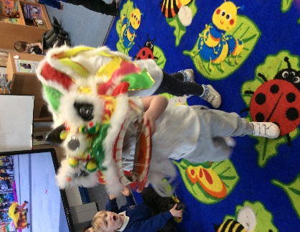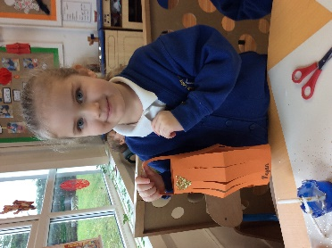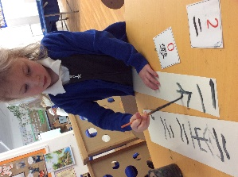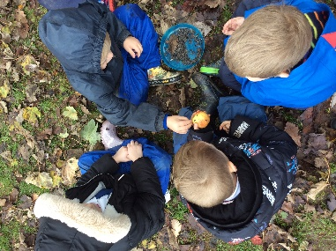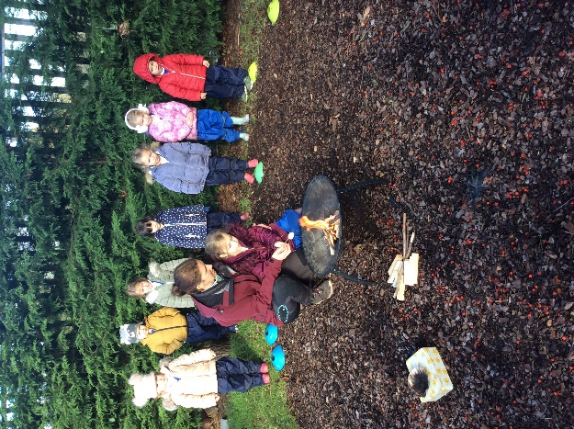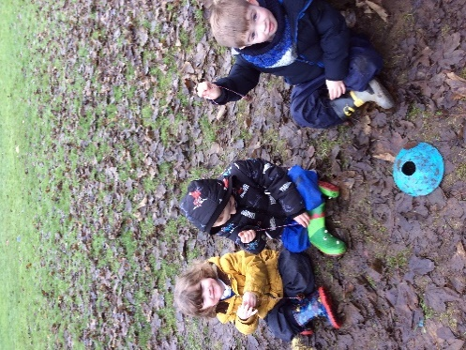  
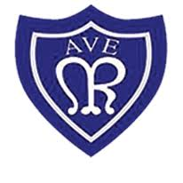

**General information:**

* A reminder that PE is on a Thursday this term. Reception children are to come to school dressed in their PE kit.

**PE Kit uniform is:**  
A plain white t-shirt  
School jumper/cardigan  
Plain black/grey jogging bottoms  
Plain trainers

* Children will be reading throughout the week, reading books need to be returned to school each day and reading at home is encouraged.
* Do your bit for attendance – please make sure that you contact school if your child is going to be absent.
* Keep up to date with what we get up to on Class Dojo and the school website.

We have thoroughly enjoyed taking part in forest school. We learned all about fire safety and how to use our natural resources to make leaf hangings, Stickman and bird feeders. We enjoy exploring the great outdoors!

We are trying really hard in our phonics lessons, learning lots of new sounds to use in our reading and writing. You can help us by encouraging us to explore reading and writing at home.

We have most recently been celebrating Chinese New Year by learning about the Chinese culture. We have been dragon dancing, making lanterns and eating Chinese food!

We hope that the year of the rabbit brings us lots of luck.

Look what we have been up to this term…

**Our Lady of the Rosary – Reception Newsletter**

**January 2023**