Homework Expectations
- Read with your child 10 minutes per day and record in the reading record.
- When word mats are sent home, support learning these words at home.
- Complete any teacher directed tasks that are sent home.

Reception

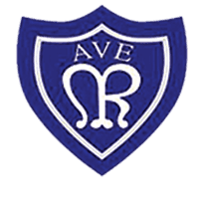

Key Stage 1 (Year 1 and Year 2)

- Read with your child 10 minutes per day and record in the reading record.
- Spelling - Spelling lists to be sent home each half term –identifying the focus spelling rule and a list of example words.
- Maths – refer to half termly Number sense focus overview.
- Complete any teacher directed tasks that are identified on the class newsletter each half term.

Key Stage 2 (Year 3 -Year 6)
- Read with your child 10 minutes per day and record in the reading record.
- Spelling - Spelling lists to be sent home each half term –identifying the focus spelling rule and a list of example words.
- Maths – refer to half termly Number sense focus overview.
- Complete any teacher directed tasks that are identified on the class newsletter each half term.

