At Our Lady of the Rosary, we follow the Sounds-write phonics programme. The children have made a great start to learning all of their new sounds and have begun to take reading books home linked to their focus sound. Reading at home with your child is a very important part of their development and I would like to thank you for your support with this.

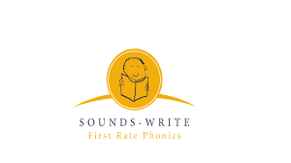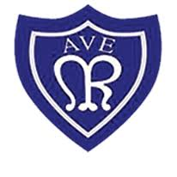

Please contact school if you have any questions. Mrs Howe can be contacted on Class Dojo or by ringing the office on   
0191 5862264

**Our Lady of the Rosary –Year 1 Newsletter**

Look what we have been up to…

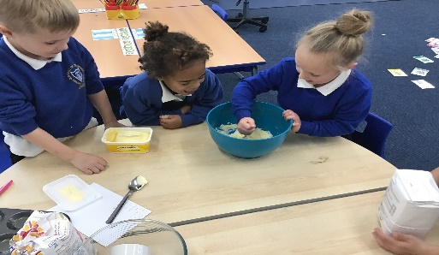

As part of the Macmillan fundraising event, the children made a shopping list when learning about managing money. They enjoyed making and decorating cakes for the school cake sale.

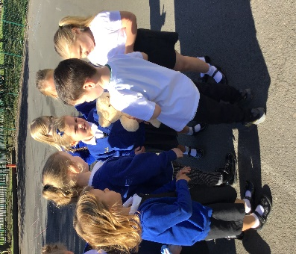

The leaves turn from green to brown and fall of the trees in Autumn

Jax

We have been learning all about the different seasons in science. The children have been investigating how the trees and leaves change from Summer to Autumn.

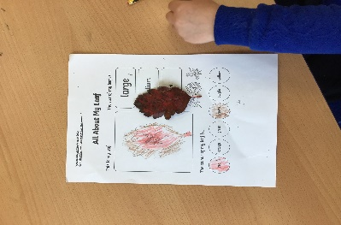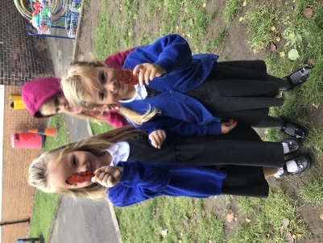

I know all the parts of a computer.

Kendal H

The children received a visit from Mr Bear! Together, they took him on a tour of the school. They wrote an excellent recount of his tour.

In computing, the children have been learning how to use a mouse and log into a computer using their own username and password. If they have computers at home it would be great if they could practise their typing skills.

Being on the school council is an important job!

Imogen G

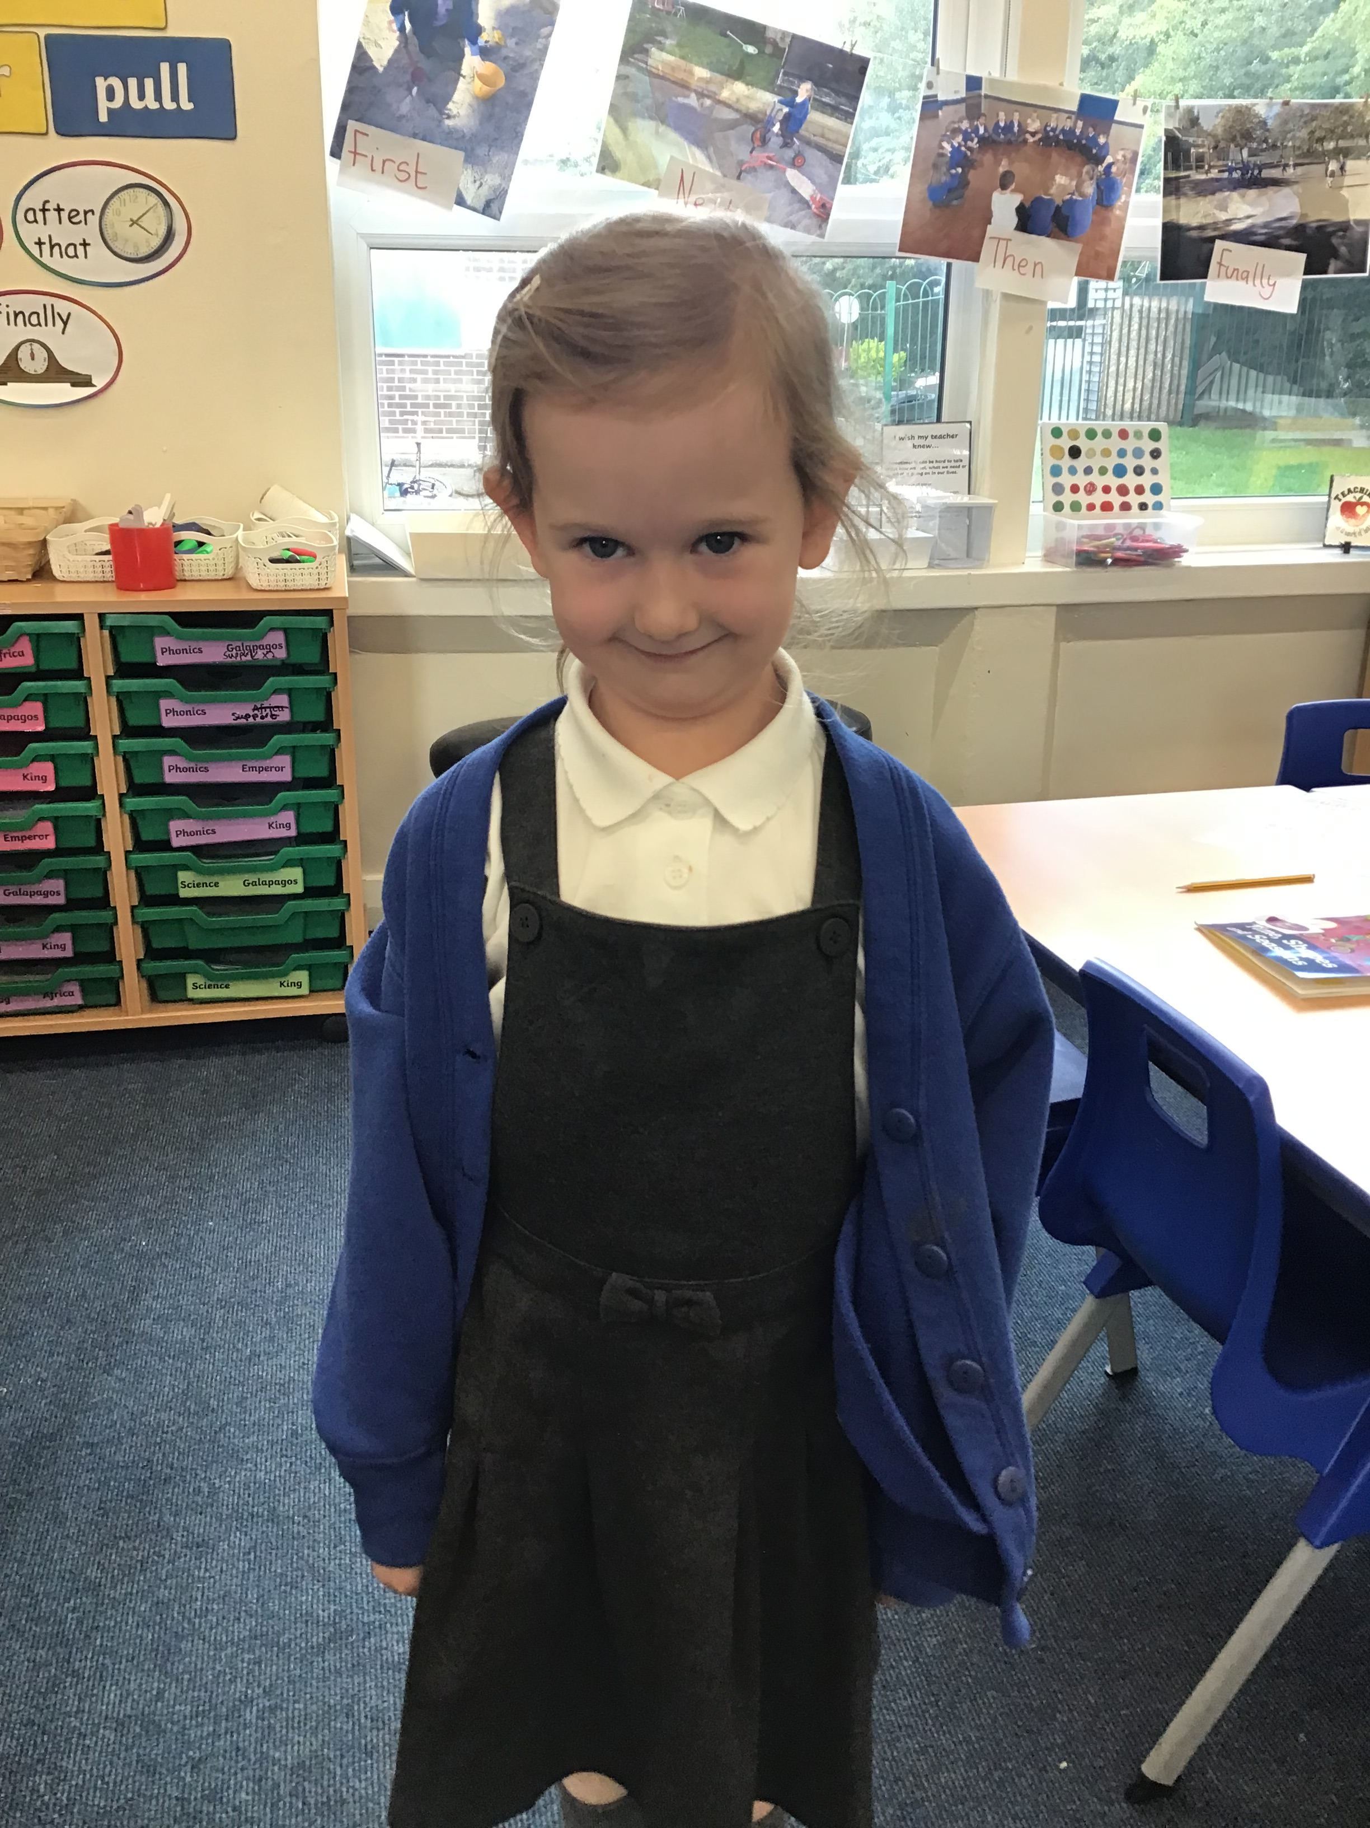

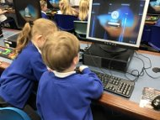

.

Here is a link to the local offer if you need any SEND support:

[Special educational needs and disabilities (SEND) and our Local Offer - Durham County Council](https://www.durham.gov.uk/localoffer)