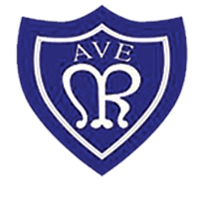
OLOTR: Year 4

Class Newsletter October 2022
Welcome back!  The children have settled back into school brilliantly. They have come in with an amazing attitude and have been ready to learn. They have been following our school rules of being ready, respectful and safe at all times. They have just recently completed their first hot task in year 4 and I am so proud of the work they have produced.  Science  Over this term we have been looking at Earth and Space in Science. The children have been brilliant at classifying rocks, and many have brought in rocks for us to explore the class.  The children then looked at how soil was formed and created their own soil using biscuits, chocolate, and strawberry laces (to look like worms). They have been able to use scientific language and have lots of fun at the same time.  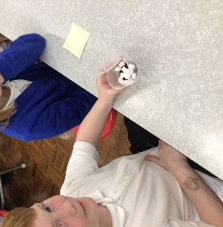  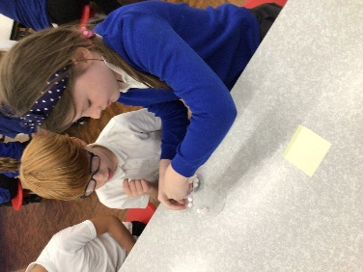  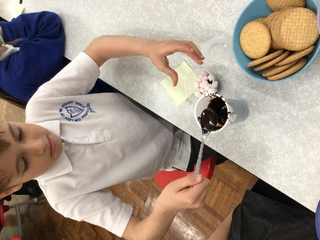 | Reading  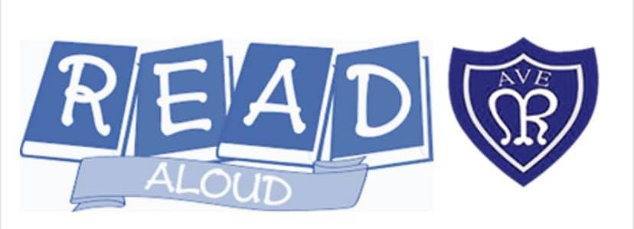  The children have loved reading Georges Marvellous Medicine in our reading lessons. They have been reading with Mrs Ord and myself at different points in the day and it has been great to see their love of reading grow. We encourage the children to read as much as possible at home and have their reading record signed to show this.  Reading is our main priority for homework, and we expect the children to read at least 3 times a week.  Times Tables  In the afternoons we have been practicing our timetables and playing timetables games!  We are running monthly battles on timetables rockstars and each half term one year 4 class will receive a prize.  This is all in preparation for their timetables check at the end of year 4.  This is going to be set as homework over the year to practice specific timetables.  You can access timetables rock star here:  www.ttrockstars.com

