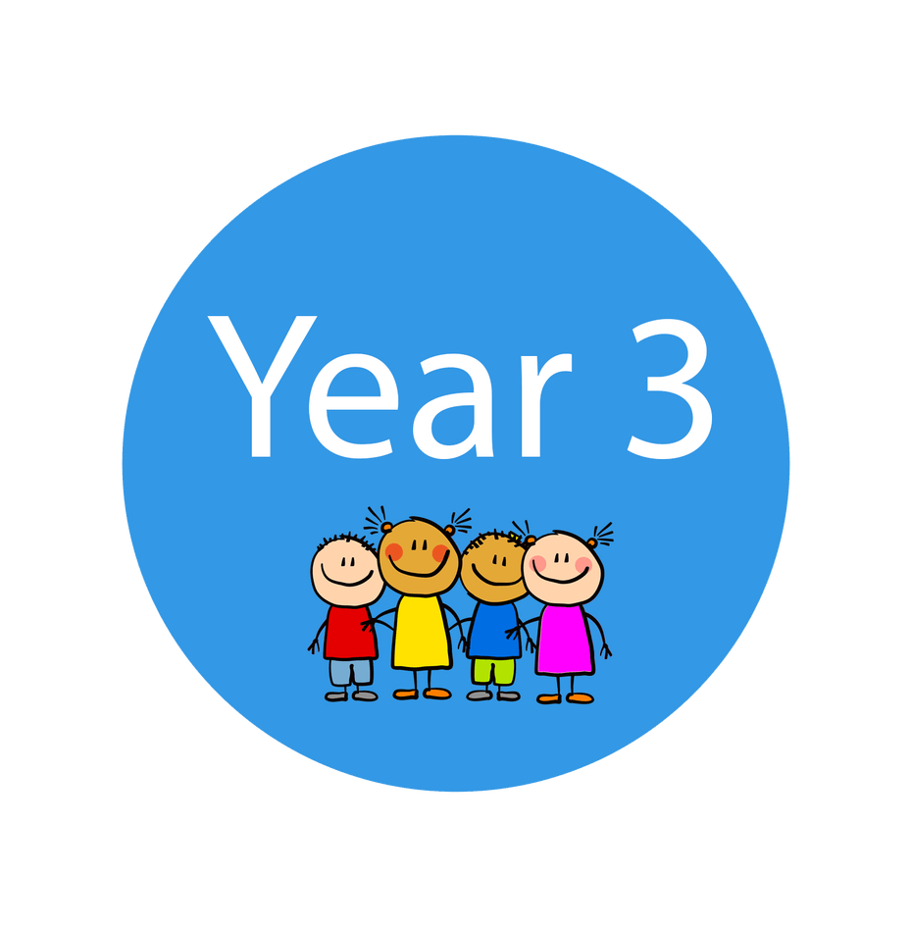
OLOTR: Miss Lawrence’s Class

Class Newsletter October 2022
teamwork makes the  dream work  Thank you for your super support at the start of this school year. It is great to see that the children are feeling settled and happy in their new classroom. They come in each day with a positive attitude ready to excel! A reminder that Class Dojo is a great way to stay in touch and to see updates of our learning journey as a class.  Our latest class attendance of the week was 87.1% This is below national expectations.  We would like to work as a team to strive for the attendance award.  Community  In our Personal Development lessons we have discussed what makes a community and how we can have a positive impact on our local environment. This links to our Geography focus on My Place in the World. Recently, we have focused on urban and rural areas including the population and the population distribution. When you are next exploring our local community, it would be great if you could discuss the features of their surroundings further. For example, landscape features such as the buildings, living near the coast or the tourist attractions.  Here is a link to the local offer if you need any SEND support:  Special educational needs and disabilities (SEND) and our Local Offer - Durham County Council | Reading  Please continue to encourage your child to bring their reading book and record into school on a daily basis. Every child reads aloud once a week by a member of the Year 3 team.  Outdoor Learning  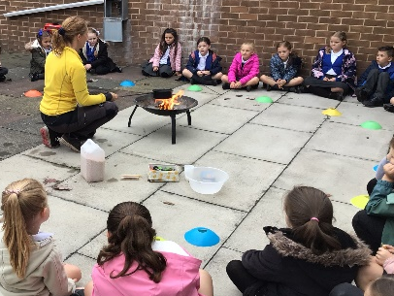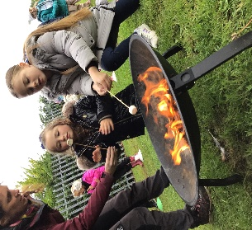  We are thoroughly enjoying Forest School being part of our weekly timetable. We are making links to a range of curriculum subjects. Also, we are developing life skills such as fire safety and teamwork.  Thank you for ensuring that your child is wearing appropriate outdoor clothing every Thursday.  Maths  In Year 3, Times Table understanding is a key target in Maths as the quicker they are able to recall these facts then the more confident they will be! Our class enjoys using songs to support their understanding.  Every child has access to Times Table Rock Stars that they can use to develop their understanding through games.

