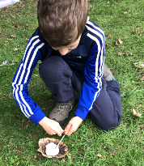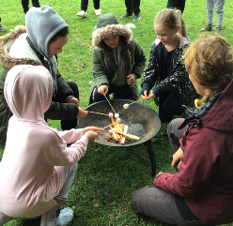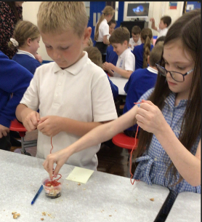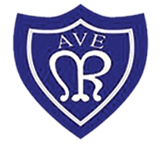

**Things to do at home**

Reading is a priority at Our Lady of the Rosary and we give the children plenty of opportunities to read at school. We are currently enjoying reading George’s Marvellous Medicine. Please continue to bring your child’s book and reading record to school daily and try to listen to them read three times a week. When reading with your children please sign their reading records after each time.

In year 4 Times Tables are extremely important as quick recall of multiplication facts supports mathematical learning. In afternoon we practise our times tables by playing games. Please try to encourage your child to access Times Table Rock Stars. We currently have a battle between both year 4 classes and the winning class and individual winner will win a prize.

Don’t forget if you ned to contact me the easier way to do it is via class dojo. Thank you all for your support so far this term.

**So far this half term**

So far this half term we have enjoyed writing newspaper reports based on our class text George’s Marvellous Medicine.

In Maths we have been learning about negative numbers, rounding numbers and counting in multiples.

In Geography we have learnt about the journey of a river including the features at various parts.

In Science we have been learning about the rock cycle. We particularly enjoyed our practical lesson making soil using biscuits and sweets.

**Forest School**

We have really enjoyed being able to go to Forest School. We have been able to link our sessions to other subjects. We have also learnt how to start a fire and fire safety. We especially enjoyed cooking popcorn on the fire

It has been great to see the children coming into school settled and happy in their new class. As a class all children have a positive attitude to learn and always try their best. Thank you all for your support so far this year.

Our attendance for last week was 92.5%, unfortunately this is below national expectations. The children are very keen to improve attendance so that the whole class can win the ‘money in the bank’ for best attendance.

**Our Lady of the Rosary Catholic Primary School**

**Year 4 Pygmy Elephants**

**Class Newsletter October 2022**